REQUEST FOR AUSTRALIAN OR STATE TITLE
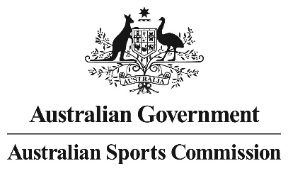
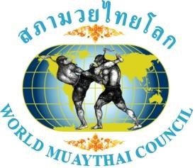
Promoter: ………………………………………………………………………….. Phone: ………………………………………………………
Show: ………………………………………………………………………………… Date: …………………………………………………………
Weight Category (kgs): ………………………………………………………. Division: ……………………………………………………

Request for: Australian Title State Title

WMC Title (A-Class / Pro MTA Pro Rules) MTA Title (B-Class / Amateur under MTA Rules) (requires MTA Exec approval for a state to have amateur titles)

Proposed match
Fighter A |  |  |  |  | Fighter B
Name: |  |  |  |  | Name:
Trainer: |  |  |  |  | Trainer:
Club: |  |  |  |  | Club:
MTA Ranking: |  |  |  |  | MTA Ranking:
WMC/MTA Titles? |  |  |  |  | WMC/MTA Titles?
Record | Win: | Loss: | Draw: | KO: | Record | Win: | Loss: | Draw: | KO:

Questions (Must be filled out by the promoter and confirmed by the MTA State Representative):
- Are both gyms / trainers registered with MTA? Yes / No (Clubs must be financial with MTA)
- Are both fighters registered with MTA? Yes / No (If your state has individual registration)
3. Last 5 fights: Opponent A
Fight # | When (Month / Year) | Who | Result (W, L, D, KO)
1
2
3
4
5

4. Last 5 fights: Opponent B
Fight # | When (Month / Year) | Who | Result (W, L, D, KO)
1
2
3
4
5

5. What other fighters have been/(if any) offered the fight/title opportunity? (please list)
Fight # | Who | Gym | Reason Not available?
1
2
3

